N E W S L E T T E R

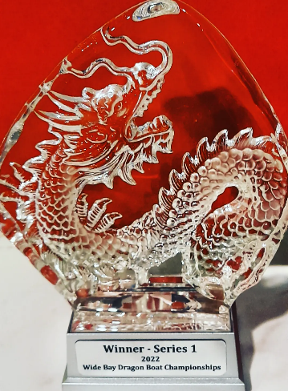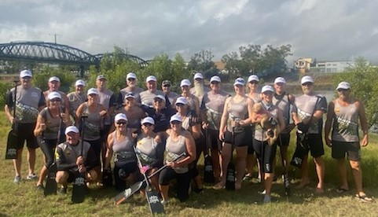
Group photo of our winning team at the Bundaberg Regatta – first in the 2022 Wide Bay Regatta Series
Although the weather report did not give much hope that the Bundy Regatta would proceed, not only did it proceed with brilliant conditions, but our enthusiastic team were there at 7.30am in preparation for being in the first race against Bundy! Our dragon boat breathed fire that day. We won every single race with times that were unprecedented.
The video footage of the final race shows just how the team performed with synchronicity and perfect rhythm.
When Paul, our President, received the trophy, we were all elated.
Congratulations to all the clubs who participated in the first regatta in the 2022 Wide Bay Regatta Series.
Thank you to the Bundaberg Dragons who hosted a very successful event.
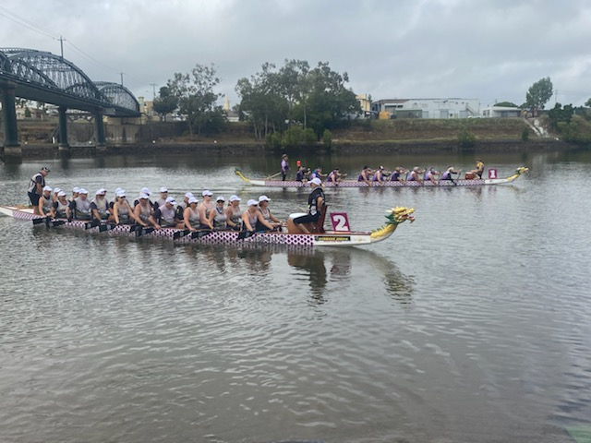
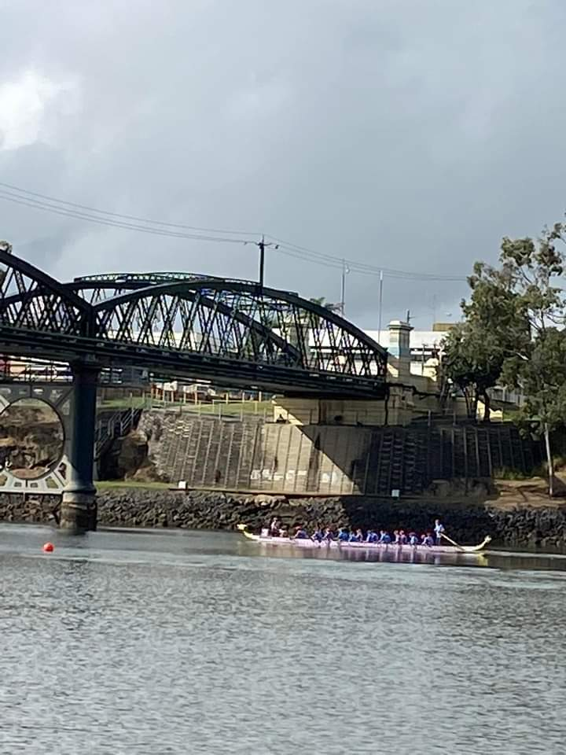
Thank you to Coach Gayle, for providing us with such great coaching and for the team for putting in hard training and, when it really counted, becoming the ‘dragon’s breath’.
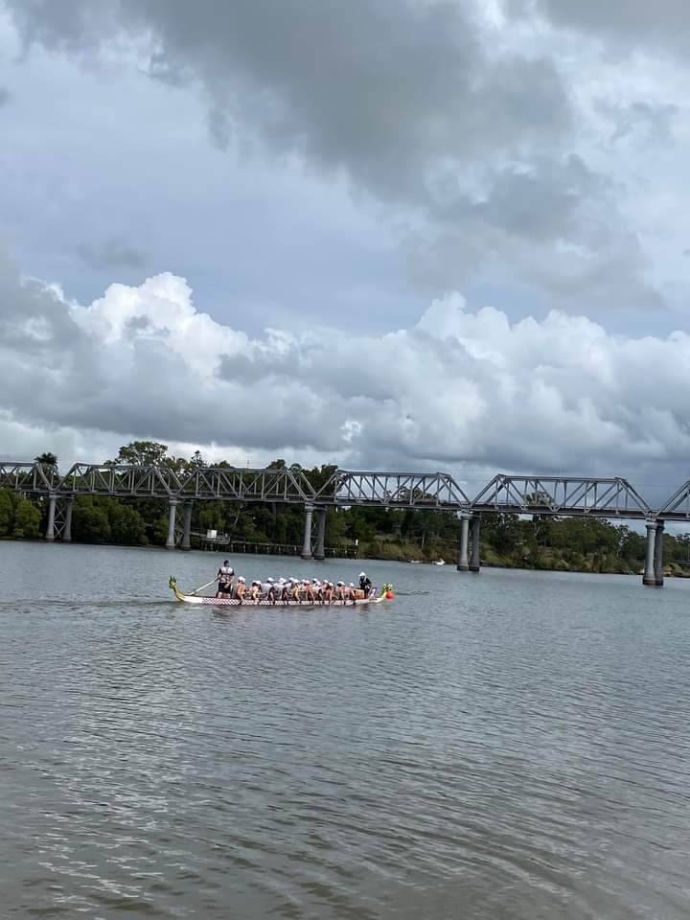
Thank you also to our sweeps, Al and Marjie, who did a brilliant job making sure we were in safe hands.
Marjie proudly flying the colours 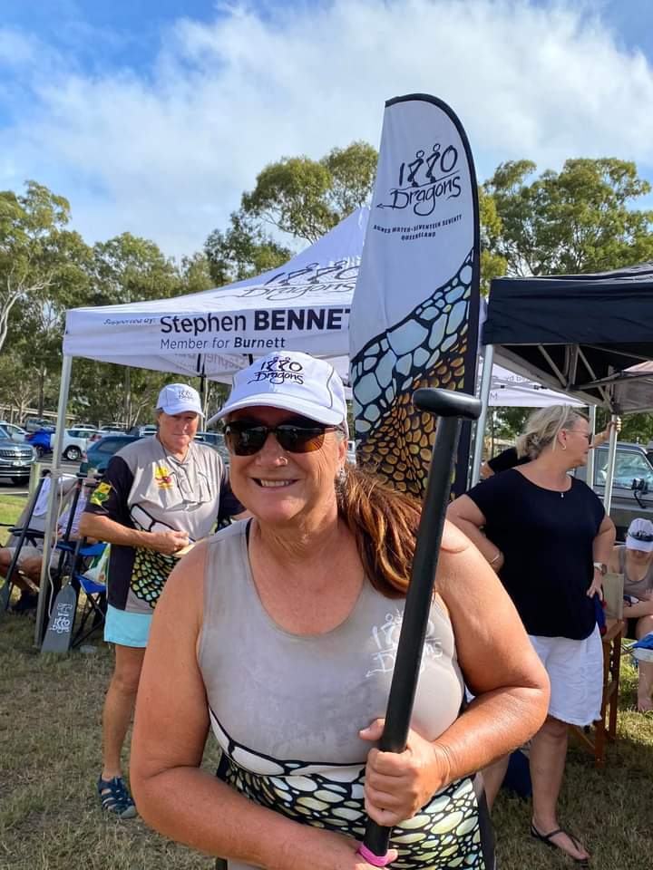

Our post celebratory lunch, for those that could attend, showed how much it meant to every team member to have been part of that regatta.
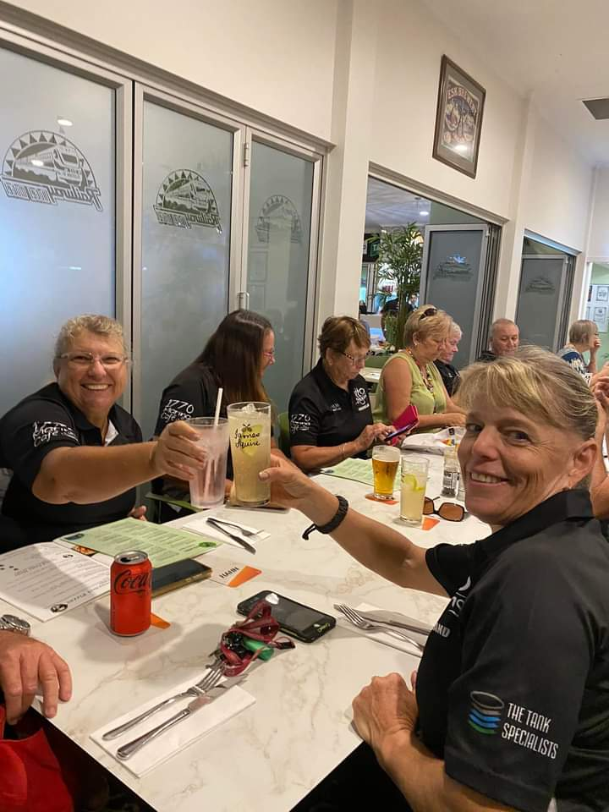

Coach Gayle’s comments:
The State Dragon Boat Championships has been the best preparation possible for this year's local competition.

Racing at States has been the best thing that 1770 could have done to prepare crews for battle against the regional teams.

The 1770 paddlers are/were already fit, strong, race-ready, and boosted with confidence after winning their three medals.

Watching the last race at the State competition gave me the strategies to work on in readiness for the "Bundy Battle"!

The race goes to the team that reaches the highest maximum speed first and stays there for the longest time. On Saturday, April 30th, the team cracked an almighty maximum speed of 15kph! I immediately broke out in goose bumps from head to toe [seriously - I have two witnesses] and knew that 1770 had a team of tigers in their tank!

On the next two training sessions, the crews again rose to a new level of performance: focussed, synchronised - paddling as one, strong and powerful. The craft travelled like it was on train tracks - rock solid, steady, speeding over the surface of the water like a missile - and I goose bumped again. The team was ready for a serious battle! We just needed to revisit and recreate that focus and performance for the Bundy regatta!

And you did ... and magic happened! I goose bumped with each race in Bundy as 1770 powered your craft strongly, confidently, convincingly ... performing at a level [or two] above that of your competitors. It was extraordinary to watch the 1770 crew paddling as one as you rose to the challenge, driving the craft down the course hard, fast, and several seconds ahead of other crews. Huge congratulations to everyone for outstanding peak performances in Bundy. Darren reckons you hit 16kph!!! Fantastic effort: Onwards and upwards, team. You can go faster for longer and shave more seconds from your times. Let’s see how fast you can go in the coming months, shall we?

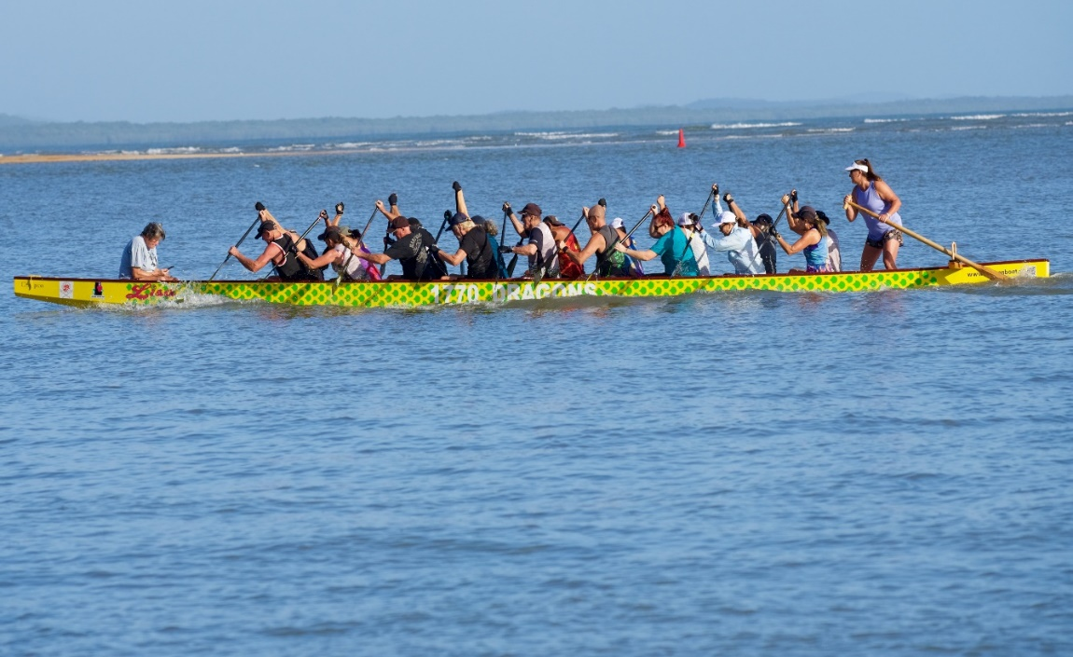
A dedicated coach & team
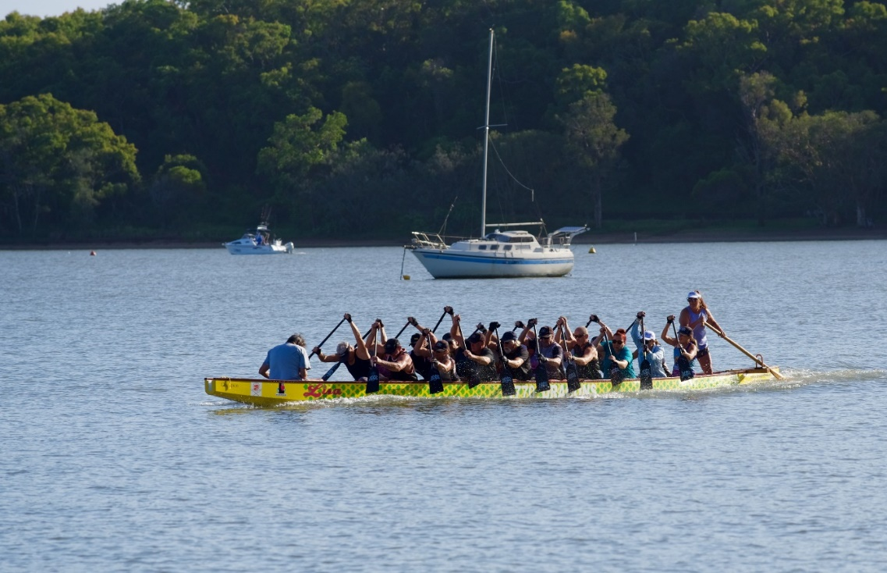
(Photos courtesy of Mark Sutton, photographer)

Message re training times from our Coach:
Please note a minor time change to Monday and Wednesday sessions in an attempt to include those who couldn’t make the 3.30pm start.
Revised start time in now 15 minutes later: arrive 3.45pm and be on the water by 4.15pm at the latest. This begins on Monday, 16 May.

Please check Team Reach for any further updates.
1770 Bowls Club
Jack Attack Challenge

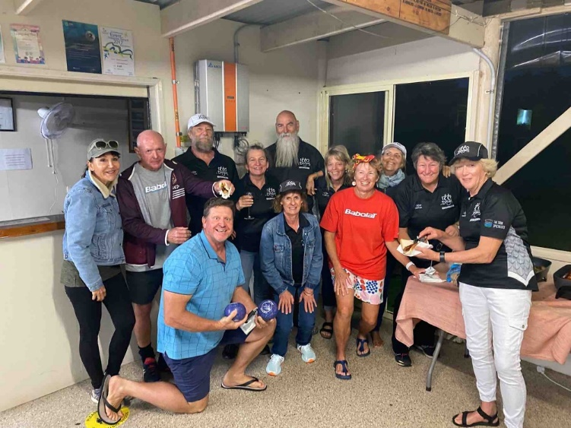

The Jack Attack challenge held on Sunday, 24 April was a huge success. Well done to the 1770 Bowls Club for putting on such a great community event. Being the inaugural Jack Attack, let’s hope that there are many more to come.

A big thank you to our two (2) 1770 Dragon teams for your sterling effort and for being part of history of the 1770 Bowls Club.

Volunteering
The 1770 Bowls Club is grateful to the 1770 Dragons who have volunteered at their Barefoot Bowls’ events.
They would appreciate our club continuing to support them with food preparation from 4pm on the first Friday of each month. The roster is in the 1770 Dragon boat van where you can place your name on the list if you wish to volunteer.
Thank you to those who have already given generously of their time, and for those who are willing to volunteer in the future!

Adventures for the Dragons abound
Thanks to Marci and Breck, our team were invited to participate in an exploration of a bike/walking track in Anderson Way in Aggie.
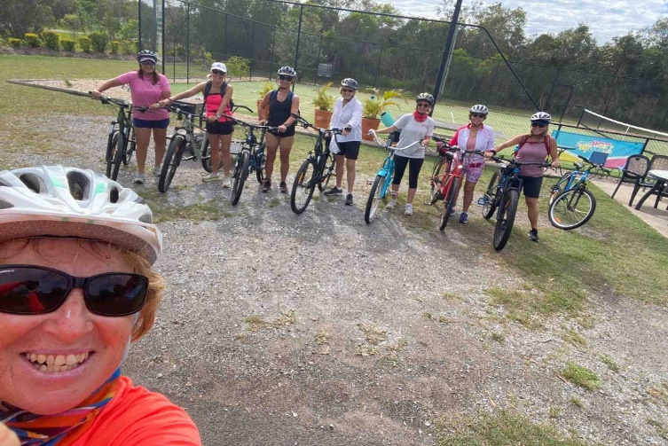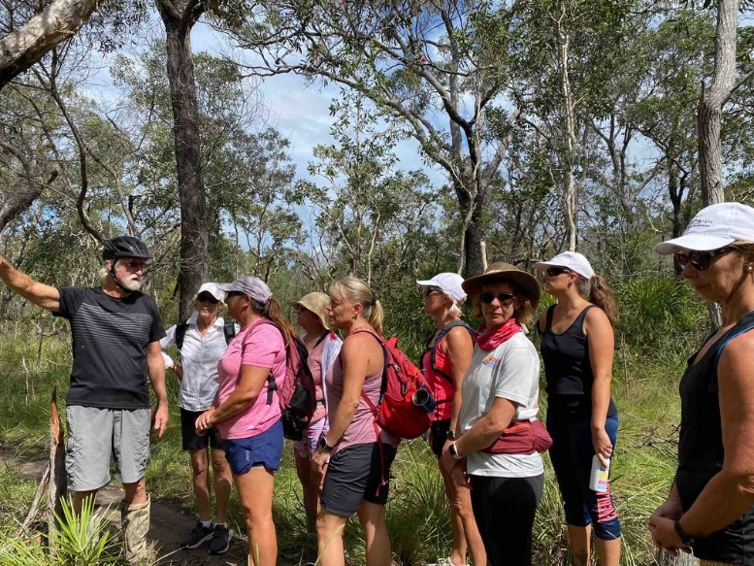
From all accounts, it was a fantastic day where everyone enjoyed themselves and got to see more of our beautiful region.

Birthdays

June: Rachel (2nd); Jen (6th); Marjie (7th); Garry (17th).

July: Vicky G (9th); Julie (16th); Keith (22nd); Ursula (29th).

Sending you all the very best wishes from your mates at 1770 Dragons.
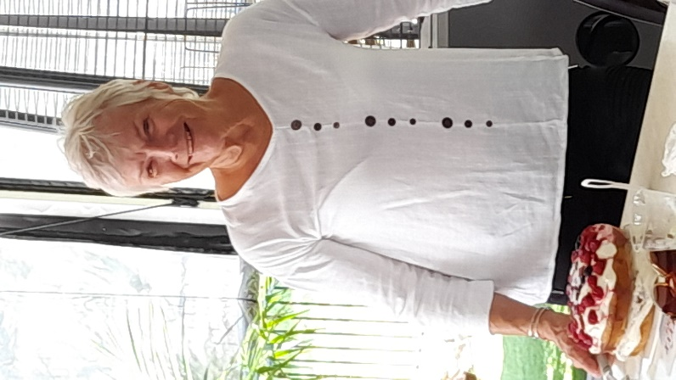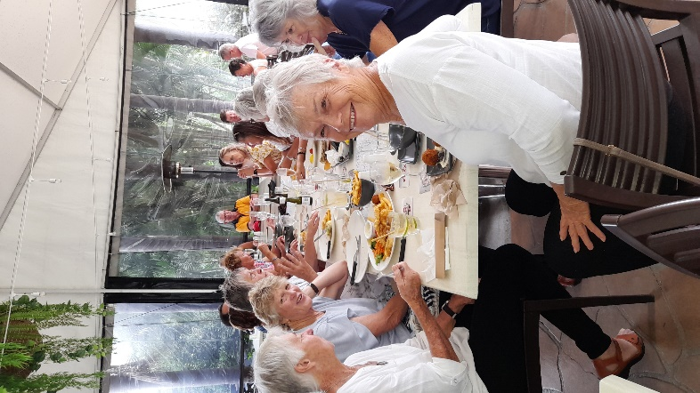
A delightful birthday lunch was held for Kathy’s birthday at the Agnes Water Tavern on Saturday 14 May.
Thanks, Marjie, for the great birthday cake. We all enjoyed the celebration, great food and fantastic company!
Upcoming Dates
for the 2022 Wide Bay Regatta Series
SUNDAY, 19 JUNE HERVEY BAY
SAT/SUN, 2/3 JULY COOLOOLA
SAT, 13 AUGUST 1770
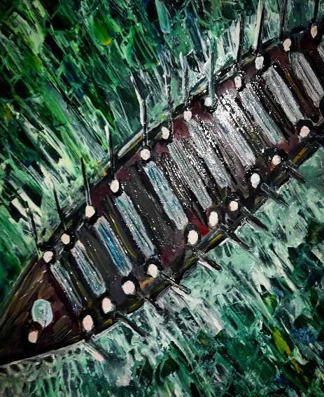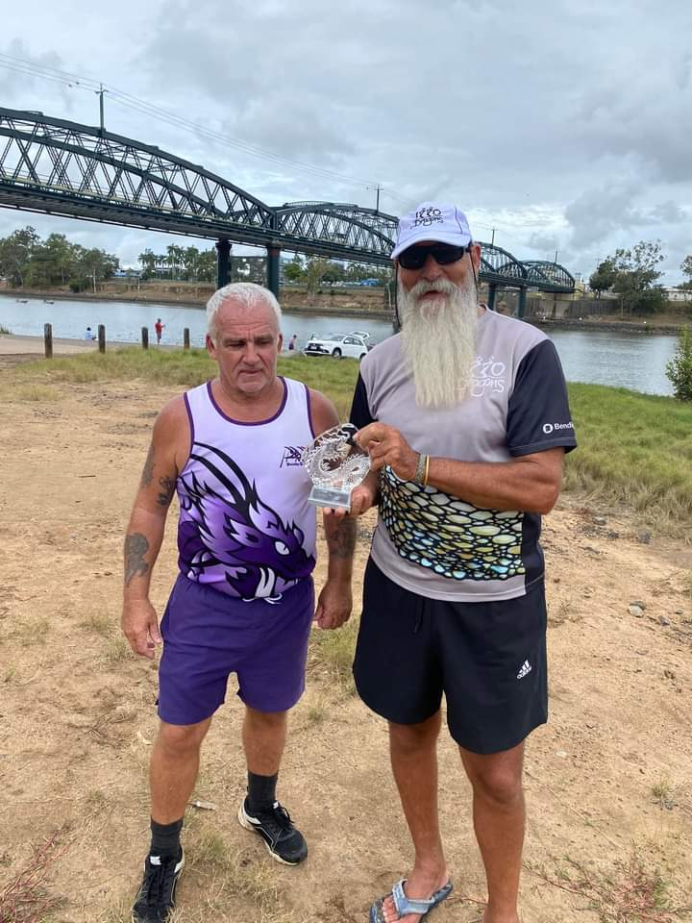
WHO ARE WE?... 1770

