N E W S L E T T E R

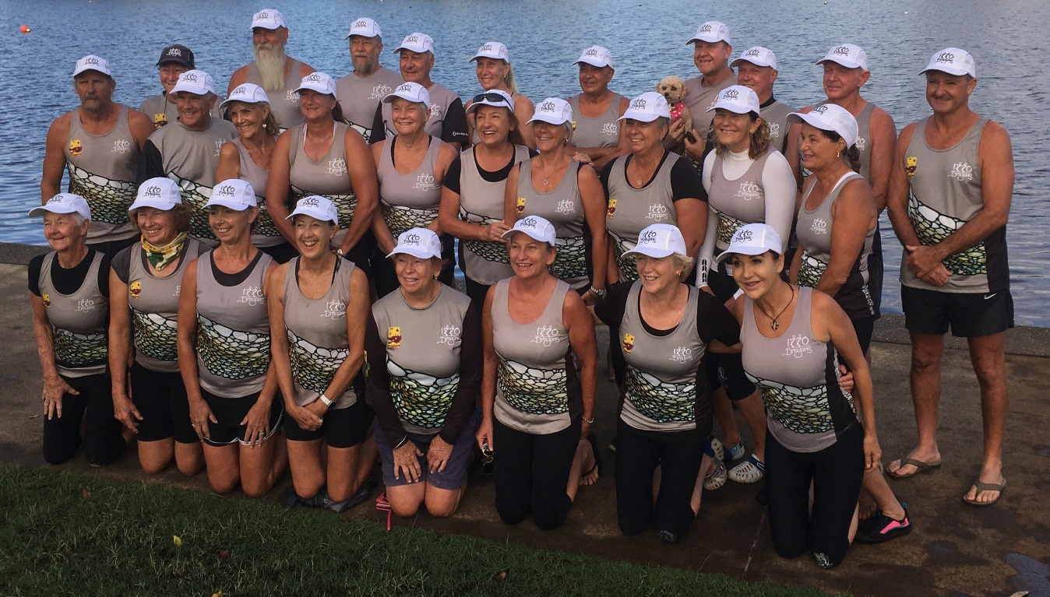 Group photo of our awesome team at the State Titles, Kawana- 12/13 March
After weeks of training, 30 paddlers from 1770 Dragons (and their supporters) were ready for two hard days of racing.

Day 1 was 500m events and 1770 crews lined up in the Premier Women’s 500m Standard Boats, Senior A Open 500m Standard Boats and Senior B Open 500m small boats.

Success came in the Senior A Open Event and a silver medal was awarded to the team.

Sunday’s competition kicked off with a 2k race and despite the early start (6.30am at the lake), 1770 placed 3rd (bronze medal) in the Senior B mixed standard boats.

Racing got serious with the 200m events talking less than a minute to compete. Again, success came in the Senior A Open standard boats with a silver medal.

1770 Dragons proudly finished with 2 silver and 1 bronze medal. A great time was had by all!

The competition was a first for a number of paddlers and a good chance that it won’t be their last!!

A huge thank you to all the team and, in particular, to our Team Manager, Lauren McGrath, who performed a sterling job keeping everyone in line. Also, thanks to Al Mason, our Club Steerer, and to Marj Bryant who steered at her first State event, which resulted in a second place. Well done, Marj!

Also, a huge thank you must go to all our club supporters who ensured the team was well catered for and hydrated. A celebration dinner was held and there is a good chance that the restaurant is still reminiscing about the night 1770 dined there!

Thank you, one and all, for a very successful and memorable weekend.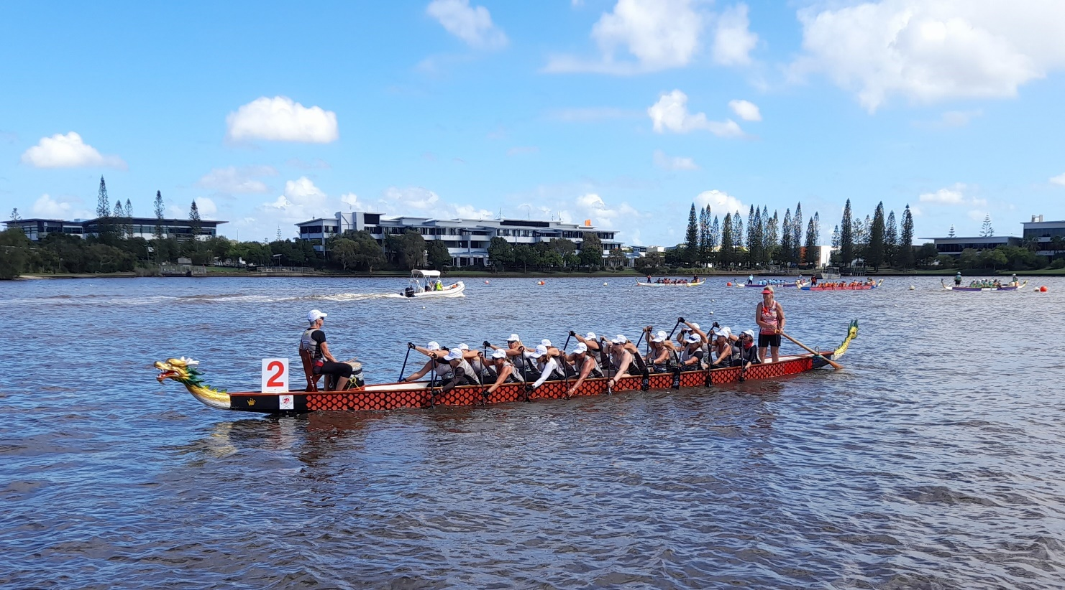

Magic Medal Moments
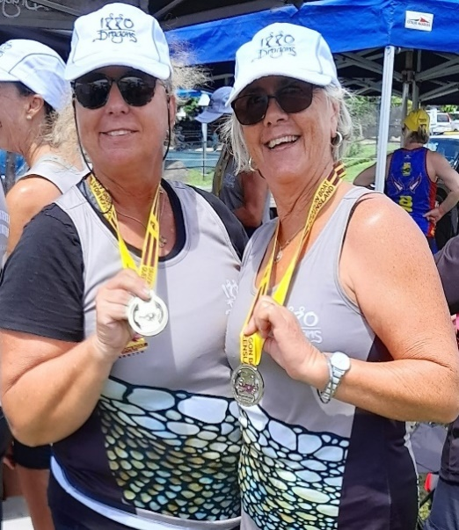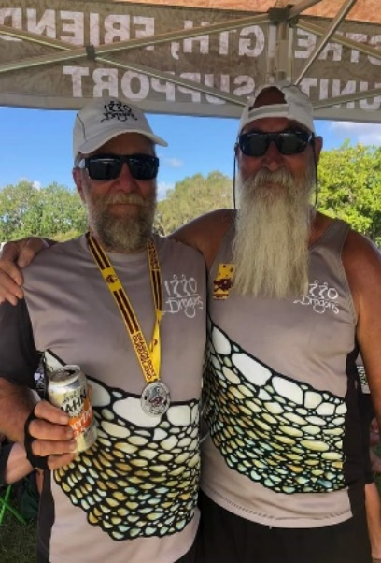
Adelle, Carol, Phil & Paul – so proud
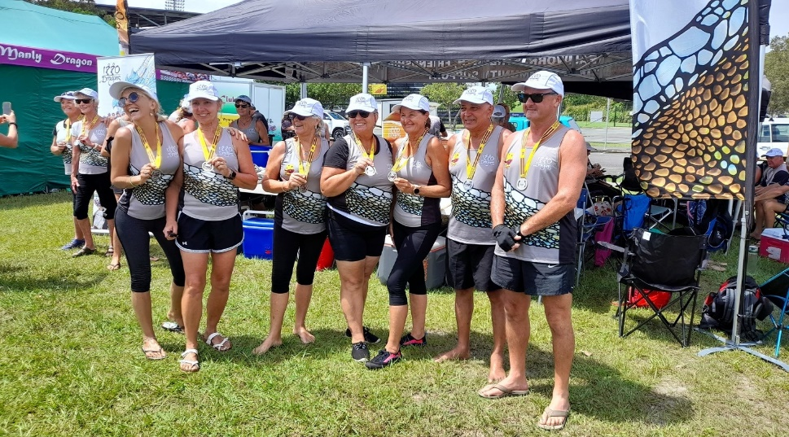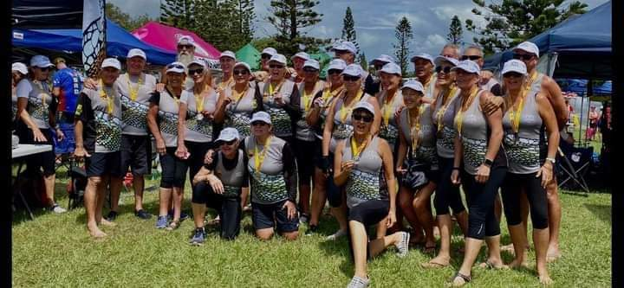
Elated 1770 Dragons’ medal winners

1770 Bowls Club volunteering
The 1770 Bowls Club is seeking volunteers to help with the food preparation for their Barefoot Bowls’ evenings on the first Friday of each month from 4pm. The roster is in the 1770 Dragon Boat van where you can place your name on the list if you wish to volunteer. Thank you!!

A Jack Attack challenge will be held on Sunday, 24 April from 3pm and we would love to have two (2) 1770 Dragons’ teams. Please let Angie know if you are interested. Some of the Dragons are already practising at the Barefoot Bowls evenings and some were able to be at the 22nd birthday celebrations of the Bowls Club on 29 March 2022!! May the 1770 Bowls Club continue to grow and have many more milestone celebrations.

March birthdays
A delightful birthday ‘1770 Dragon girls’ lunch was held for Jan’s birthday at the Agnes Water Tavern. Well done, Kerrie for making a ripper birthday cake! We all enjoyed the celebration and the great company!
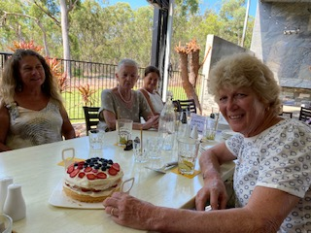

There were also a couple of other birthdays that snuck in since our last newsletter which included birthdays for Roger and Julia. Happy birthday from all the Dragons to you both! Hope your year ahead is full of good health and lots of successes!

April birthdays
Fiona Casu (5th); Larry Casu (11th); Jean Imbert (7th); Breck Morrison (30th) and Kath Young (14th). Sending you all the very best wishes from all your mates at 1770 Dragons.

Coach Jen’s comments:
Hi Team, Firstly, a big thank you to our Team Manager, Lauren, Assistant Coach, Gayle and Roger, our trolley boy, and everyone else who made the States such a great success.
Thank you to all our paddlers – new and old – putting in hard training on and off the water. I couldn’t be prouder of our team.
Our results were fantastic.
I know that we will be back next year even stronger.
Great memories!
Cheers, Jen
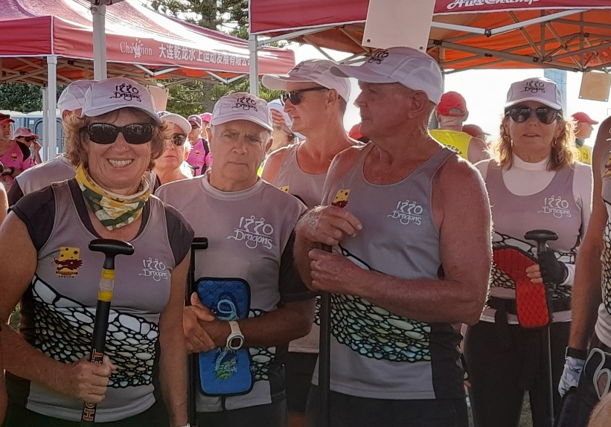
Photo: Angie, Wayne, Larry, Gary & Jen – ready to conquer
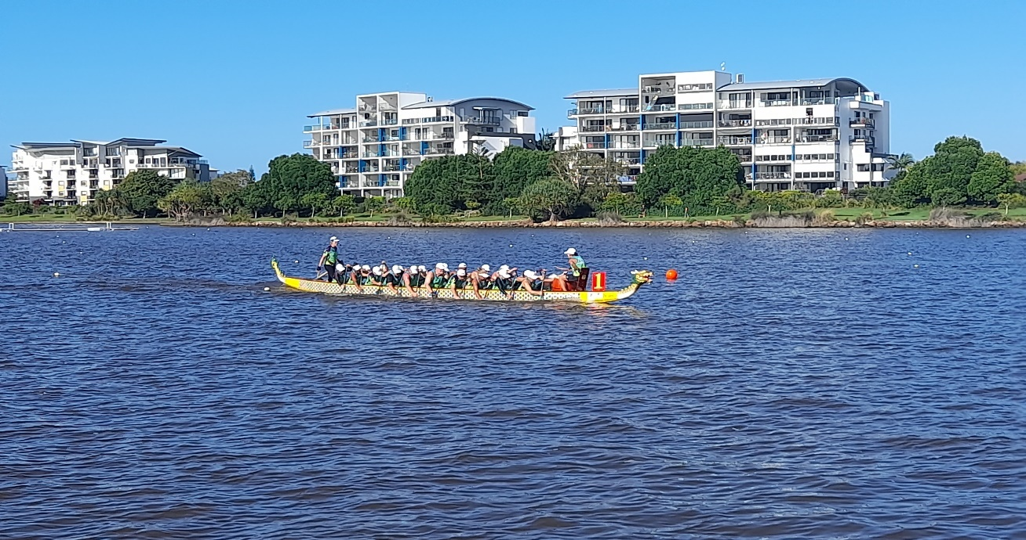
Congratulations! A great team effort at the States

Team Manager, Lauren’s comments:
Since September 2021, the 1770 Dragons’ membership has seen a phenomenal growth. It’s great to see the influx of new members (some new to our town) and to see their enthusiasm. Thank you for your commitment and your contribution.

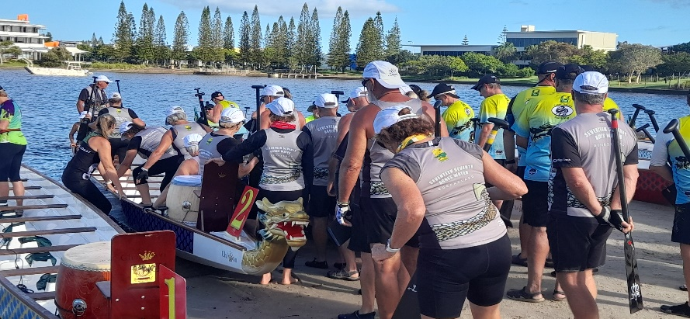
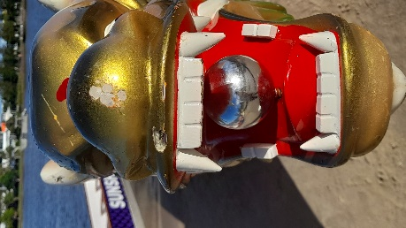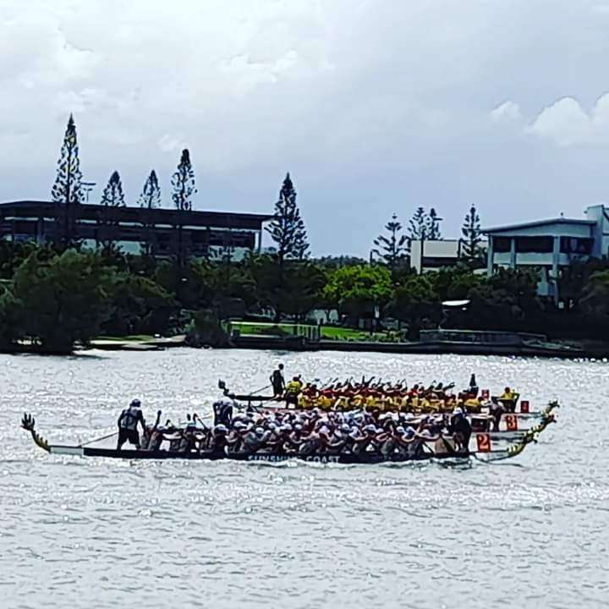

Wide Bay Regatta series
The next exciting regatta is just around the corner. If you are intending to enter the Wide Bay Regatta series, please put your name on the board in the 1770 Dragon’s van (the more the merrier)! Let the training begin!
Here are the dates:
Saturday, 7 May, Bundaberg
Sunday, 19 June, Hervey Bay
Sat/Sun, 2/3 July, Cooloola
Saturday, 13 August, 1770
WHO ARE WE?... 1770

