N E W S L E T T E R

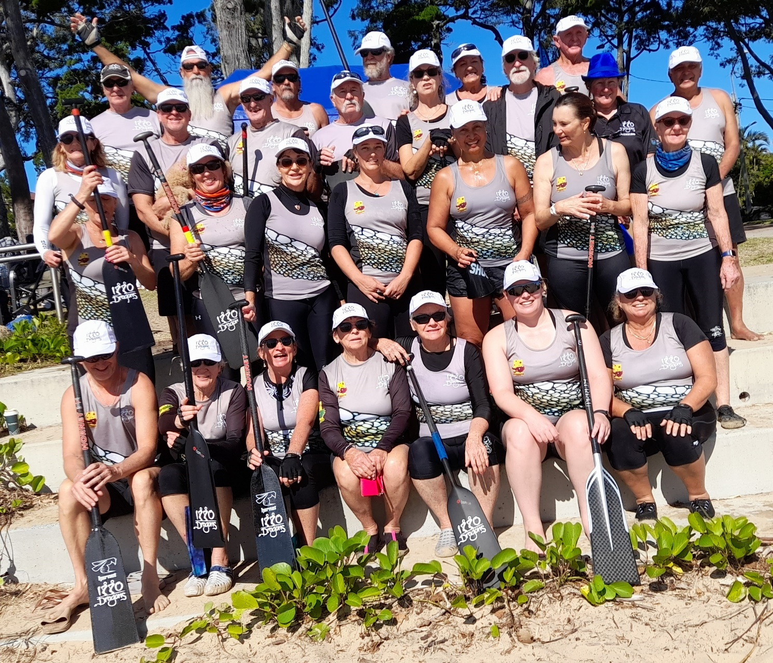

Group photo of our dynamic winning team at the Hervey Bay regatta

(2nd regatta in the Wide Bay series)
What perfect conditions we had at our Hervey Bay Regatta (2nd in the Wide Bay Regatta series) on Sunday, 19 June 2022. All the teams were fired up and ready for another exciting competition.
Thank you to Coach Gayle, for providing us with such great coaching and for the team for putting in hard training and, when it really counted, becoming the ‘dragon’s breath’.

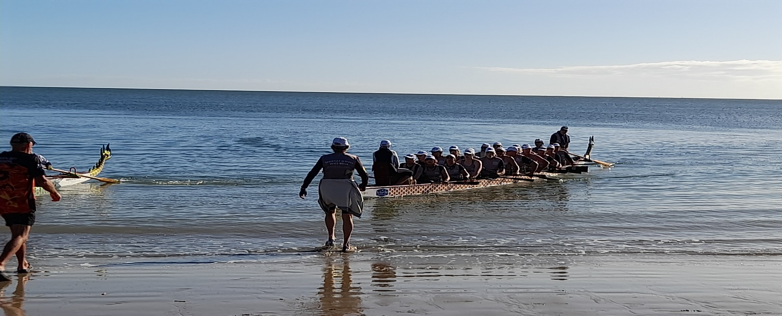

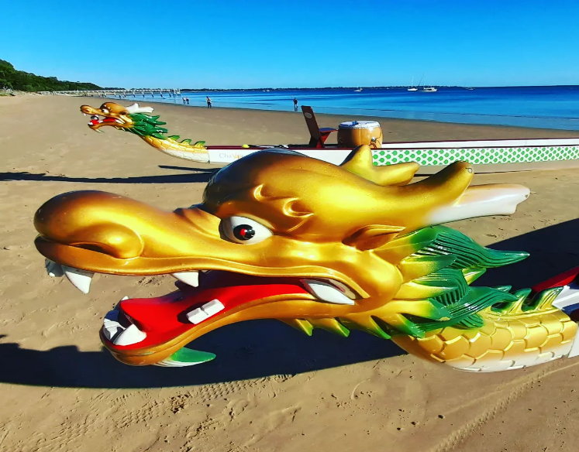
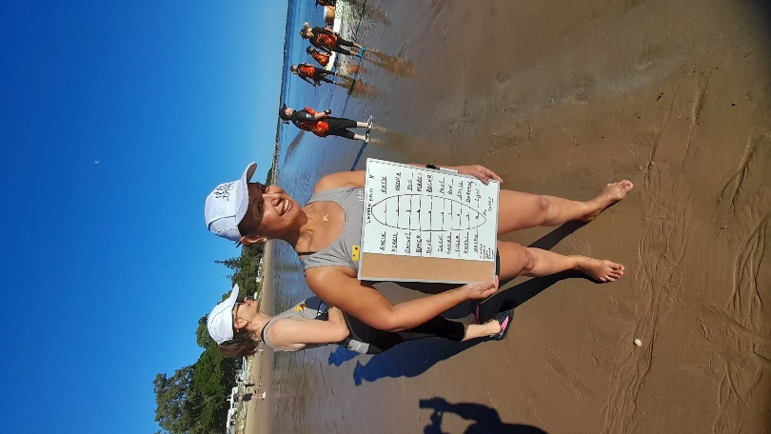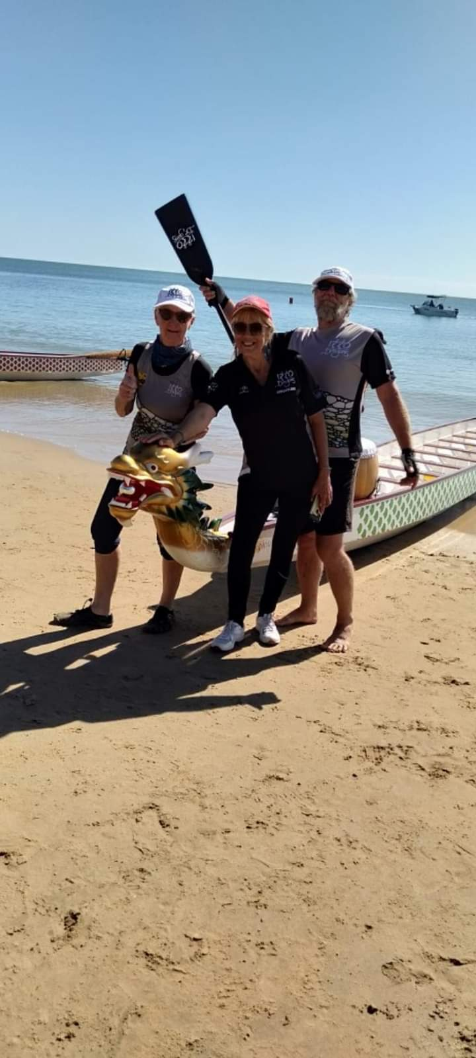
Thank you to everyone for making the day so much fun and to our Team Manager, Coaches, Sweeps, Drummer and Cheer Leaders.
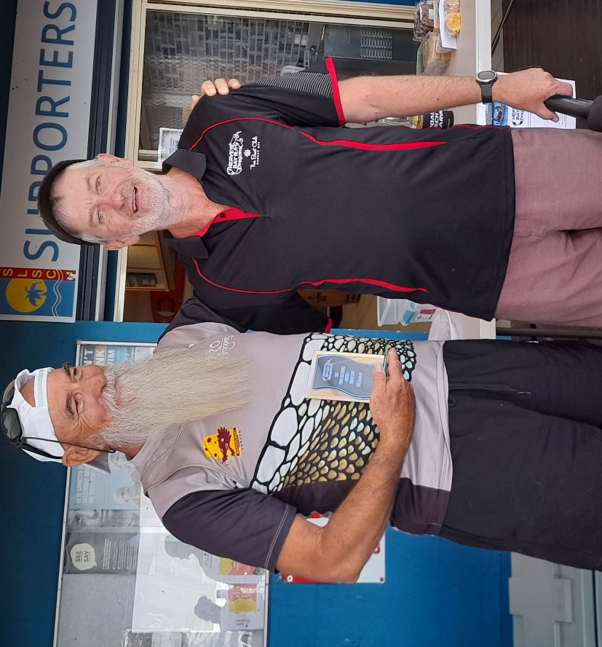
Paul, our President, proudly accepting the Hervey Bay Regatta trophy on behalf of the 1770 Dragons.
Thank you to the Hervey Bay Dragons who hosted a very successful event. Their raffle prizes were very impressive – I think 1770 Dragons did very well (particularly one of our members who won several prizes)
VOLUNTEERING
Bowls Club
Art Show 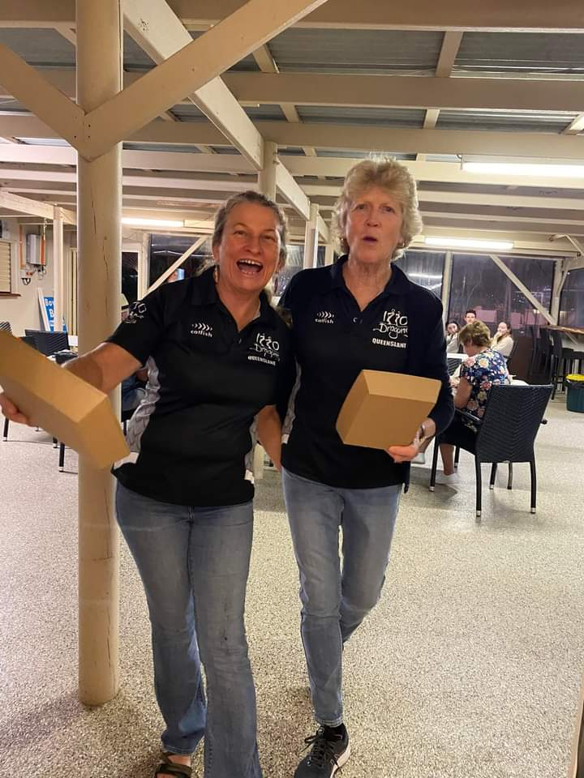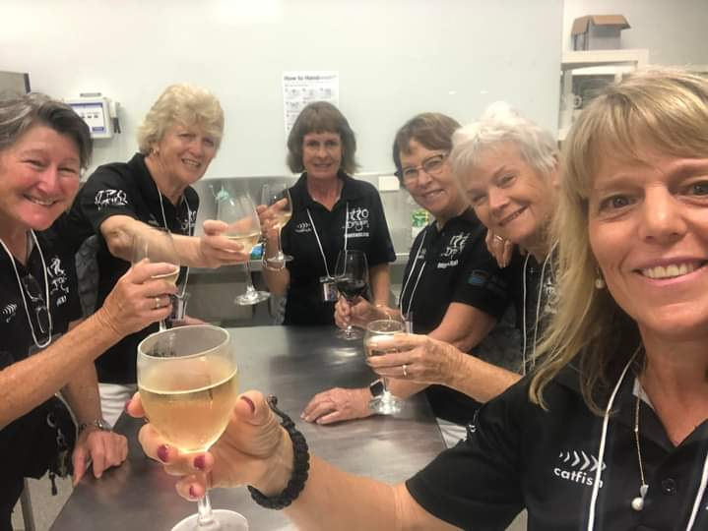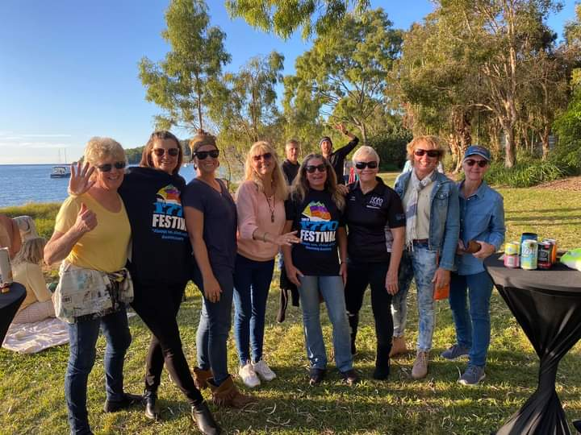
1770 Festival
Our dynamic winning team at the Cooloola regatta
(3rd regatta in the Wide Bay series)
The 1770 Dragons had a huge weekend at Tin Can Bay on Sat/Sun 2/3 July 2022. As predicted the weather was wet, but thankfully, not windy. We all know that Dragon Boating is a water sport, so a little bit of rain was not going to affect our seasoned 1770 Dragon crew.
Team members gathered at 7am Saturday morning ready for the 3rd round in the Wide Bay Regatta series.
The other teams were from Bundaberg, Hervey Bay and Cooloola.
For the first time this season, 1770 Dragons lost, not once, but twice, to the Hervey Bay team.
Fortunately, the final race saw 1770 Dragons and Hervey Bay fight it out, and in true form, 1770 Dragons came home the victor.
Celebrations were on hold as the next event kicked in straight away with the infamous Diamond Dash. This event is a dash for cash, also known as a Steerer’s race.
Congratulations to the 1770 Dragon’s newest Steerer, Marjie Bryant, as she tackled the course with enthusiasm as did her team of 12 keen paddlers.
Although, not in the running for the prizes, it’s a sure bet that Marjie will be back having a crack at this course again next year. Well done, Marjie!
On Day 2 of the Cooloola Regatta teams competing were from Mackay, 1770, Sunshine Coast, Brisbane and the Gold Coast.
1770 Dragons nominated to be in both A and B Divisions. Luckily, the sun came out and a dry day was had by all which made for the feature of dressing up a brilliant spectacle. All the teams made such an effort. It was so much fun when each team paraded their unique designs to the admiring crowds.
Talented members of our 1770 Dragons spent many hours designing, sewing, painting, their ‘deck of cards’ outfits. Members and supporters looked stunning in their costumes. As the 1770 Dragons paraded their ‘deck of cards’, they sang ‘The Gambler’ giving the cards even more abundance.
Overall, the event was a huge success on all fronts and excellent performances were put in with 1770 qualifying both in A and B finals.
The Brisbane team, Lakers/Manly, won B Division and Mackay Stingers took out A Division. 1770 collected their trophies for third in both events. It was a photo finish, which made for an exciting race.
Congratulations to Cooloola Dragons for putting on a great weekend full of events and to all the teams and their supporters for making it so much fun.
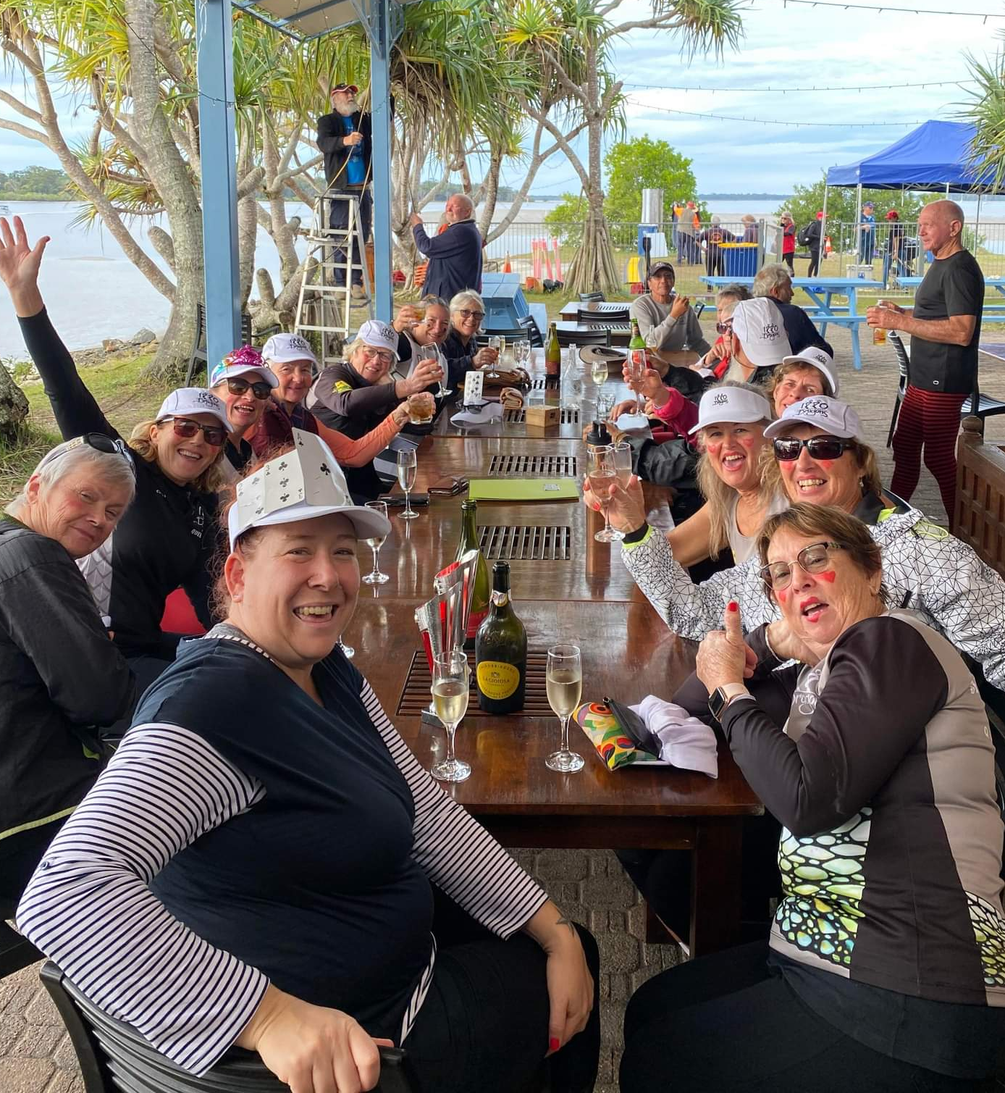
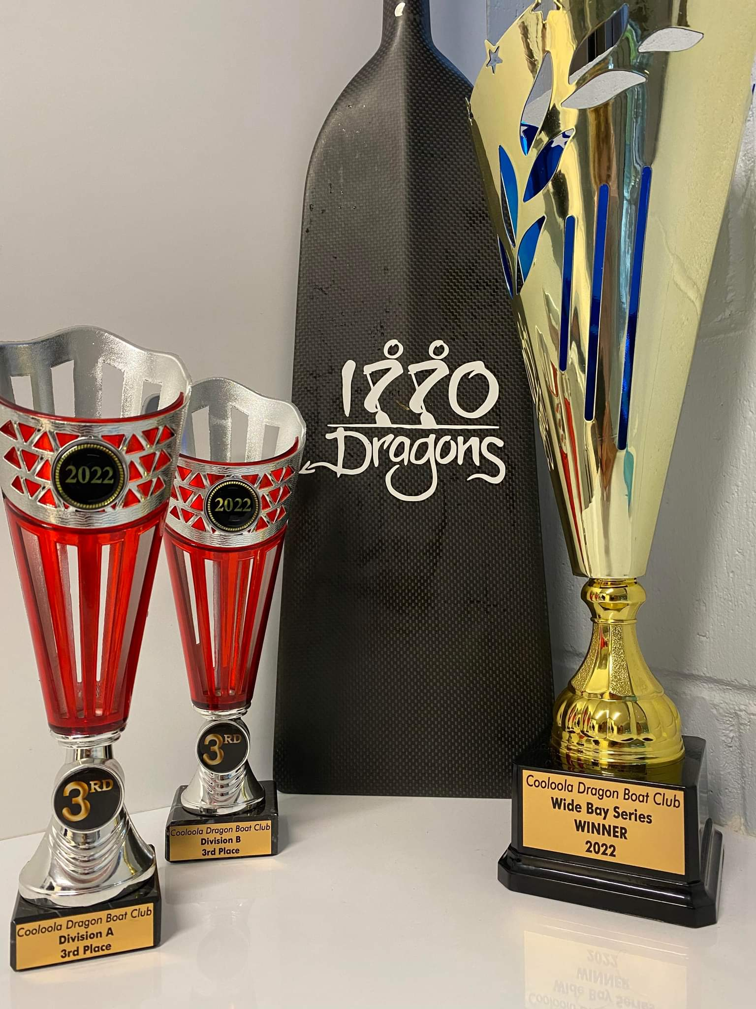

A brilliant weekend with great memories and great fellowship.

‘Deck of Cards’ Dynamic Dragons
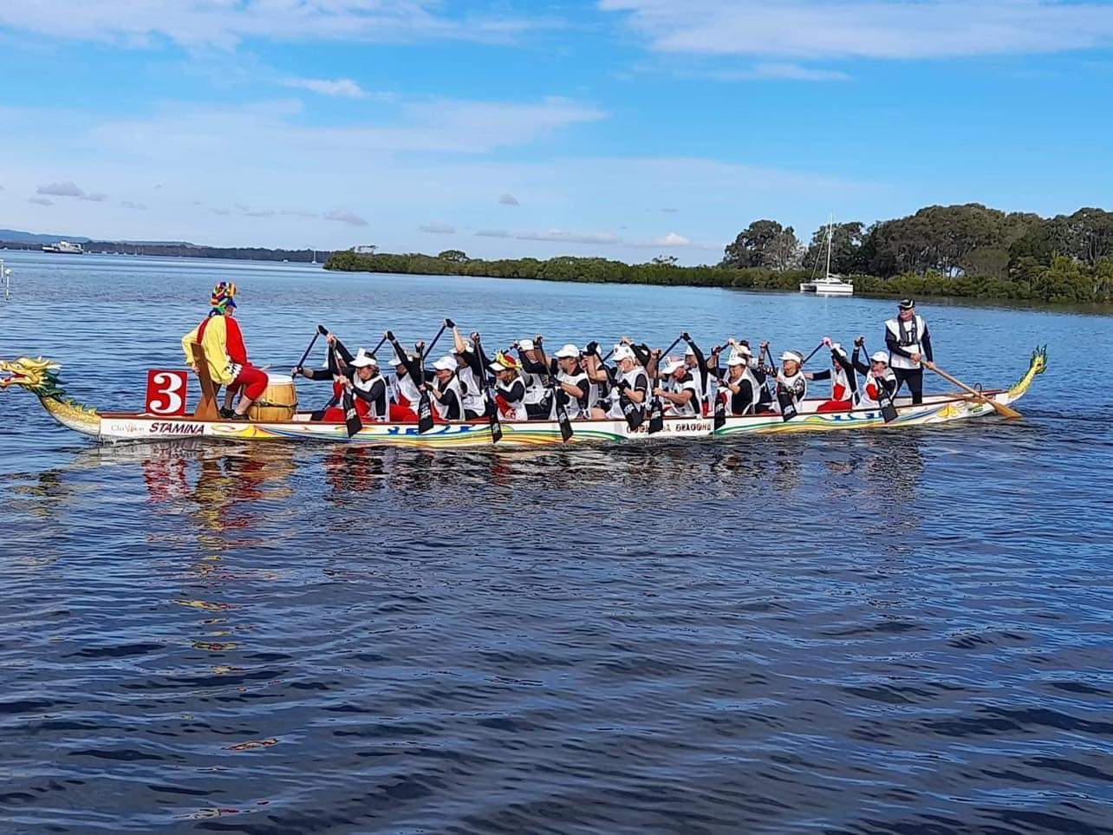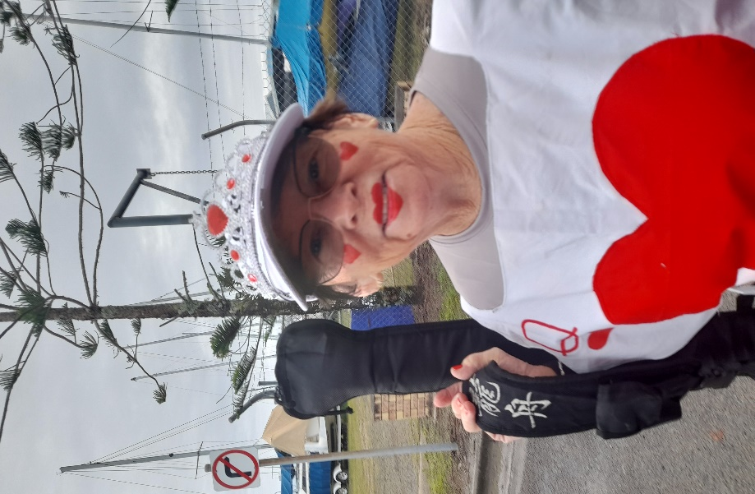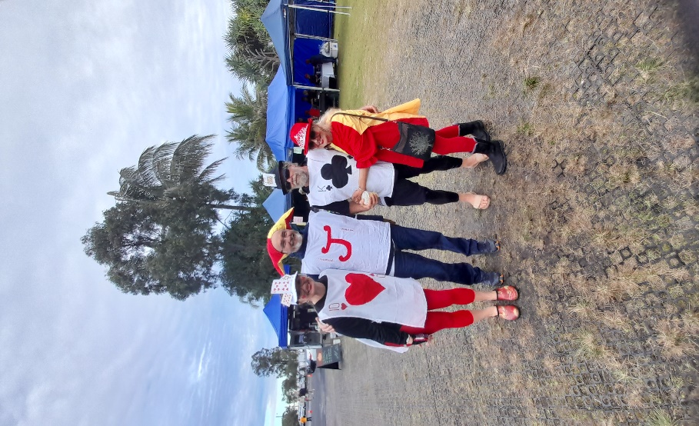

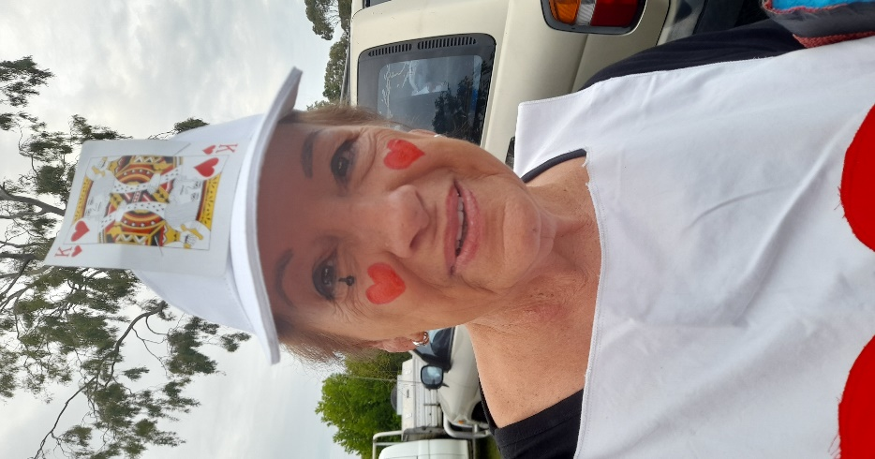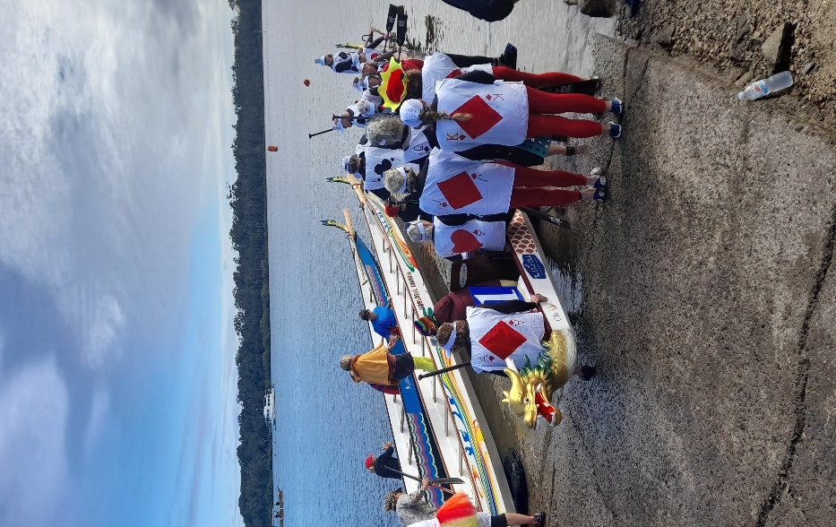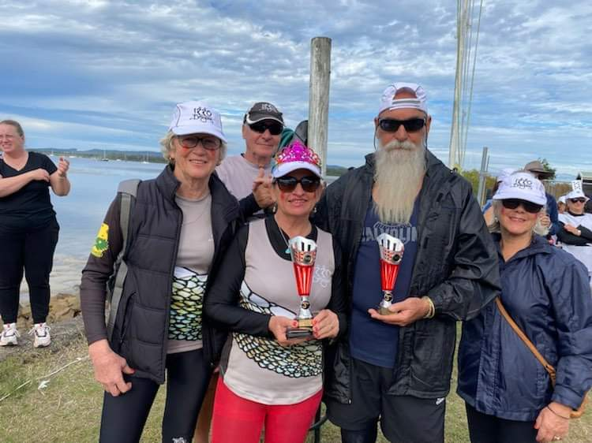
Congratulations 1770 Dragons

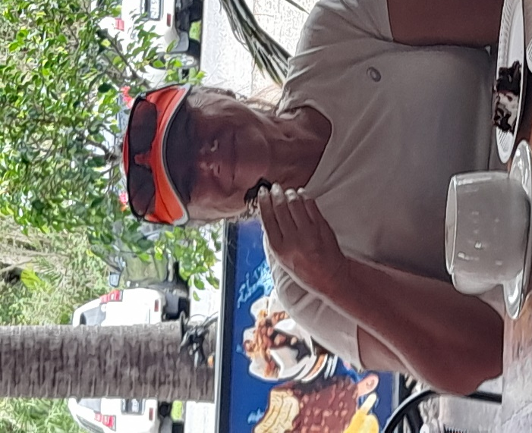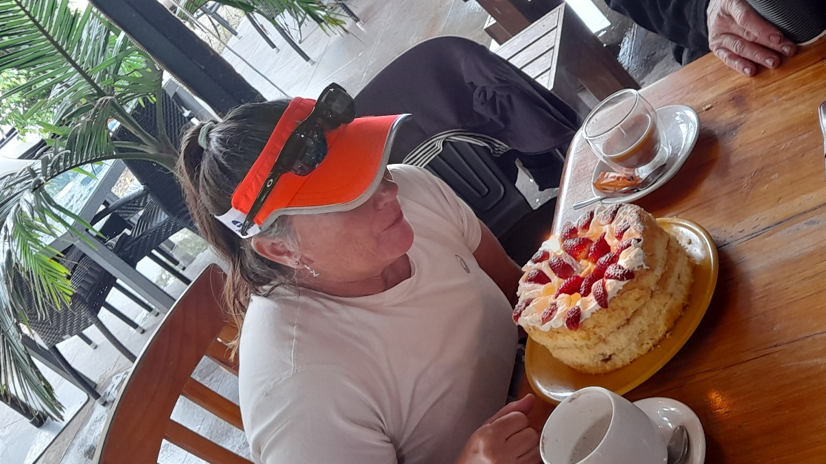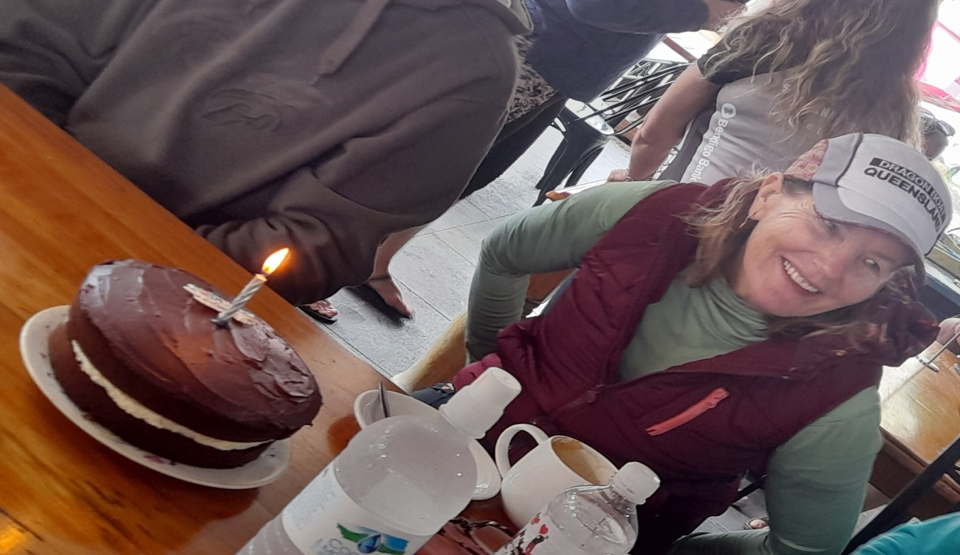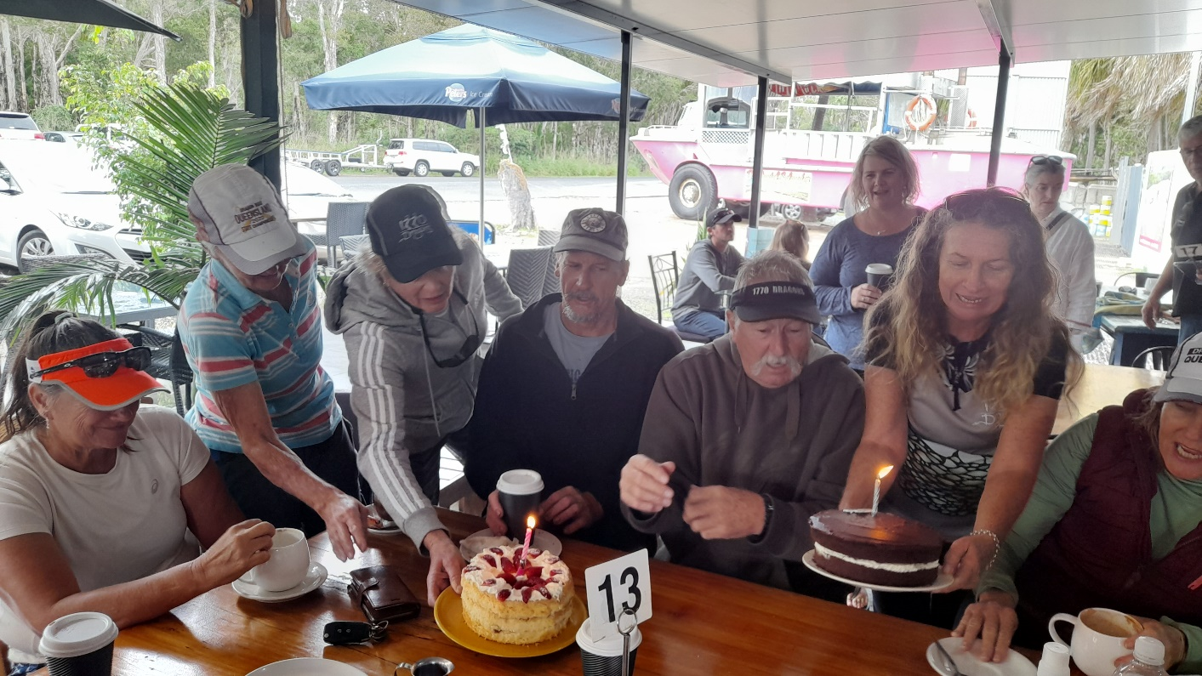

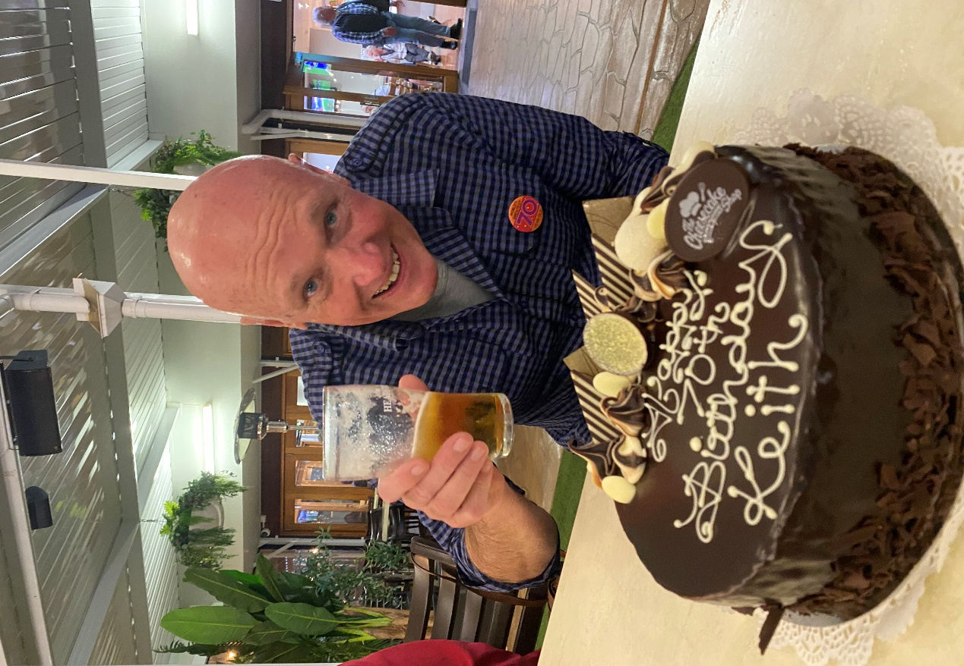
BIRTHDAY CELEBRATIONS
There was much to celebrate in June and July with 1770 Dragon birthdays galore. We hope you all had a brilliant time. We are looking forward to the next two months with the following birthdays:

August: Robyn (15th); and Phil (20th).
September: Paul (1st); Roberta (6th); Brendan (10th); Allan B (17th); and Sandy (24th).

Sending you all the very best wishes from your mates at 1770 Dragons.

1770 Van Poster Upgrade
It is with much appreciation to Marci and all those who worked alongside her, to make it possible to upgrade our 1770 van poster, which looks absolutely brilliant. Well done, Marci and team!

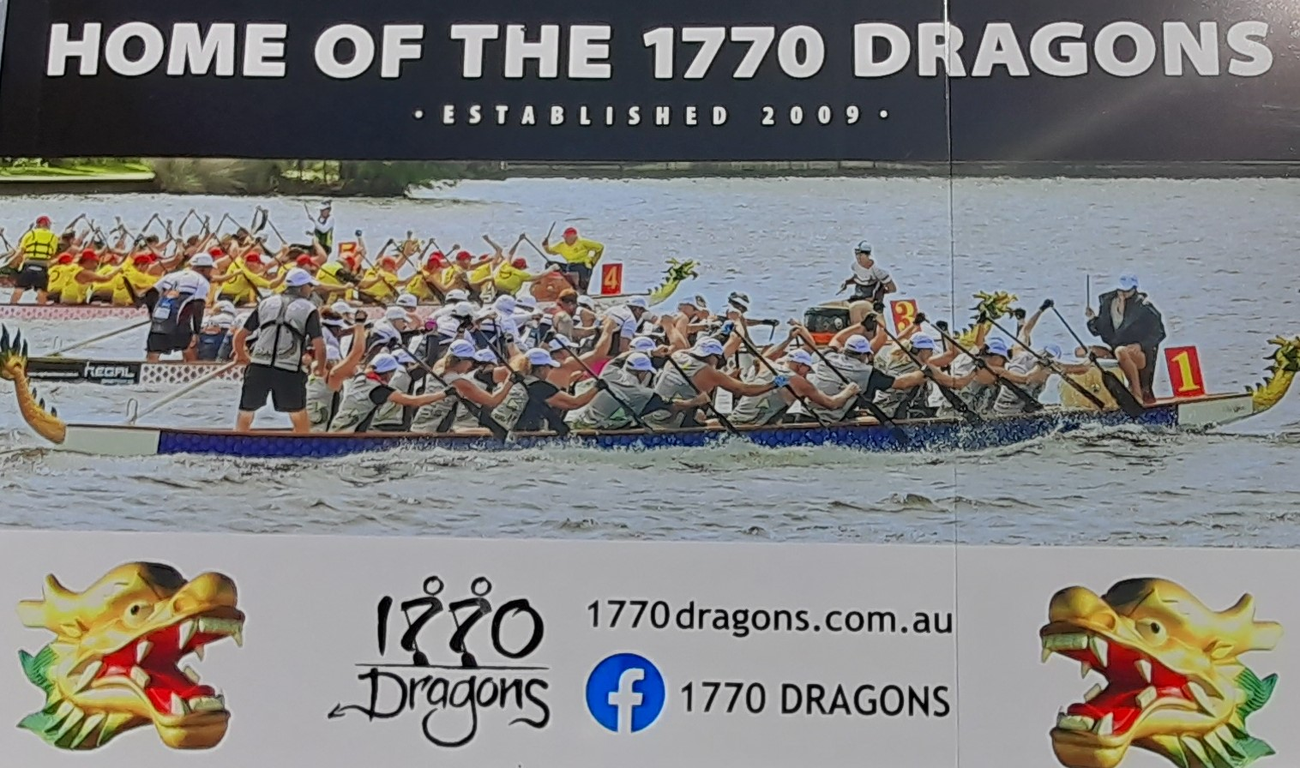

Congratulations Rachel

Congratulations to Rachel who was invited to the Auroa’s Camp on 4/5 June in Sydney.
The 1770 Dragons are proud of you.

What do the 1770 Dragon’s feel after their training?
Last Saturday (16 July) as I was a Cheer Leader and not paddling/drumming, I had the unique opportunity of asking some of our Dynamic Dragons, how they felt immediately upon stepping off the Dragon Boat after a hard training session in challenging conditions. Here’s what some of them had to say:
‘rough’
‘stormy’
‘euphoric’
‘captivating’
‘aha aha’ (said with enthusiasm – but the only person who could say two words)

Upcoming Date Claimer:
Final Regatta in the 2022 Wide Bay Regatta Series -
Saturday, 13 August
(on our home turf)

WHO ARE WE?... 1770

