N E W S L E T T E R

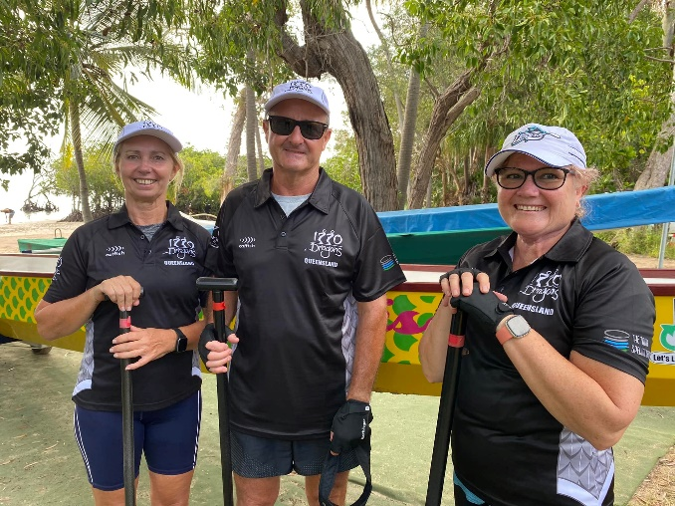
Welcome to all our new members
Here’s a fantastic snap of our most recent members… Fi, Larry and Dawn. It’s great to see all the new faces in our team. There’s been a swell of interest in the past few months, which is absolutely brilliant. Thanks to all the enthusiasm of past and present members, 2022 is shaping up to be a great year. ‘Who are we?’ …. ‘1770’

Next upcoming Event:
State Comp – 12, 13 March - Kawana
Training Times:
Mon 4pm; Wed 4pm; Sat 7am
Please remember to place your name in Team Reach well prior to each training session to enable the coach to be able to select the team’s best positions in the dragonboat – this is particularly important with the States being just around the corner!! Remember, if you need any merchandise, prior to the States, please see Lauren. Also, as part of our training, it helps tremendously if team members can arrive at 4pm Mon/Wed and 7am on Sat so that we can be on the water within a half an hour from arrival giving us time to do our warmups (thanks to Ursula) and to get the boat ready and the team in position. Thanks to everyone for their commitment to the training in the lead up to the States. Well done – a superb effort!!
Aussie Day Celebrations
and our farewell to Daisy
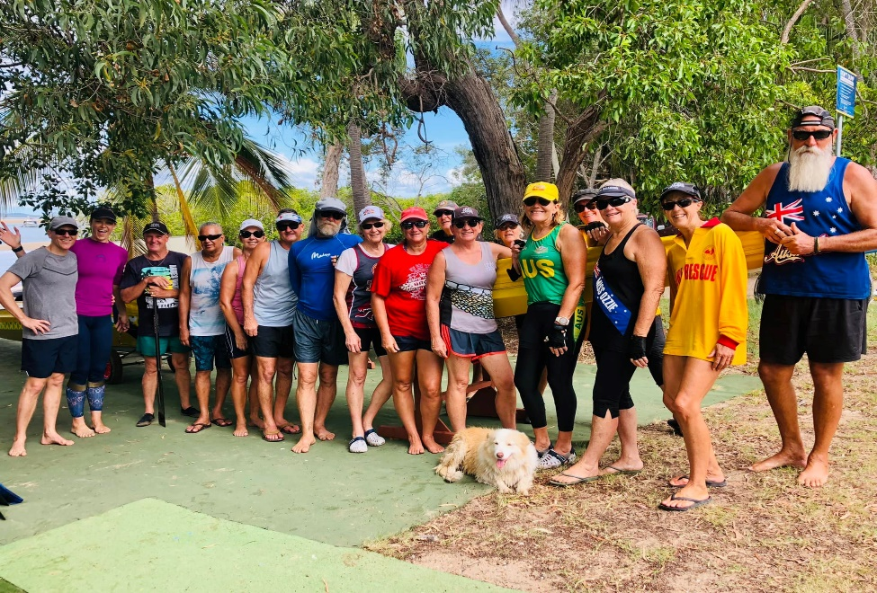

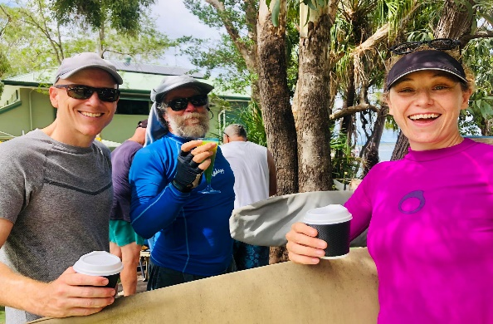
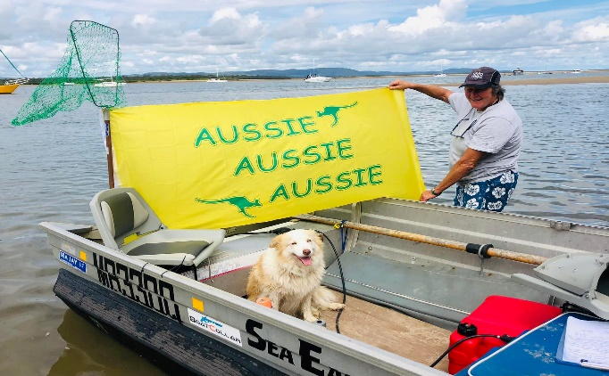Gail proud to be an Aussie .. and Ruby, too!
It was a bitter-sweet paddle on Wed 26 January, as we enjoyed our 1770 Dragons’ Australia Day B-B-Q (after we had put the hard yards in with our early morning paddle), however, we also farewelled Daisy who, due to her husband’s overseas work commitments, is not able to continue paddling with 1770 Dragons while she lives away. We are hoping that Daisy will return to 1770 Dragons when the time is right in the future. We wish them both the very best for their next chapter.
Bowls Club volunteering
Just to let everyone know that the 1770 Bowls Club is seeking volunteers to help with the preparation for their Barefoot Bowls’ evenings on the first Friday of each month from 3pm. The roster is in the 1770 Dragon Boat van where you can place your name on the list if you wish to volunteer. February’s roster is full, which is great. Thank you!!
A special farewell to Pam and Al Lawry–
Life Long Membership of 1770 Dragons
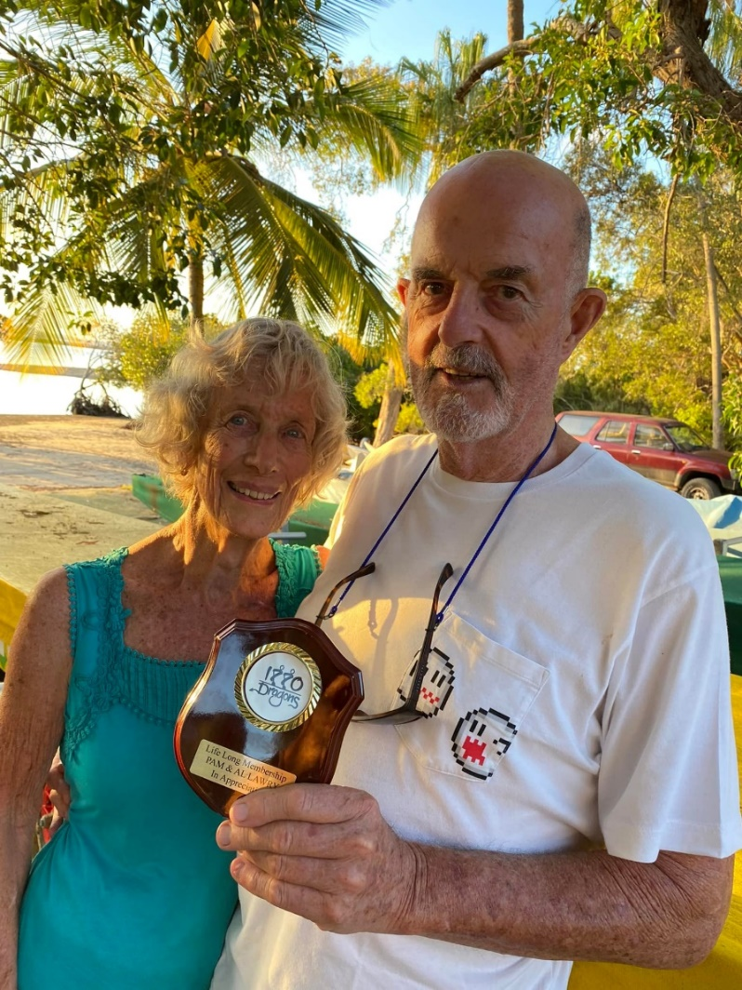
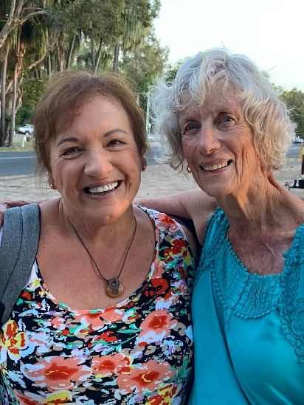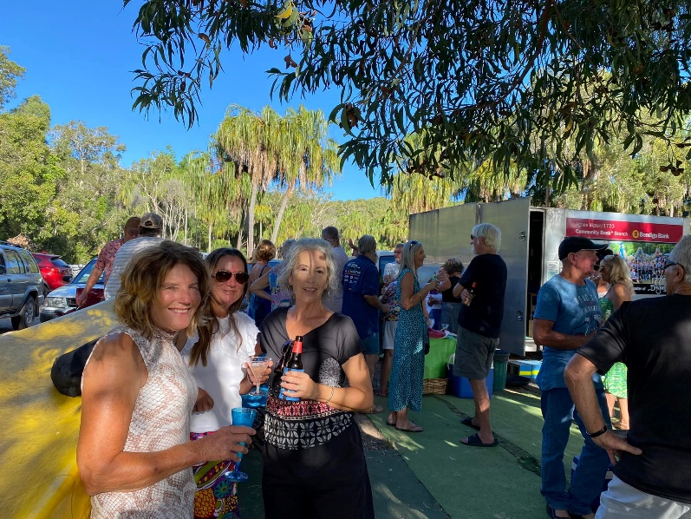
What a special afternoon gathering to honour Pam and Al for their tireless efforts as long-standing valued members of 1770 Dragons worthy of Life Long Membership.
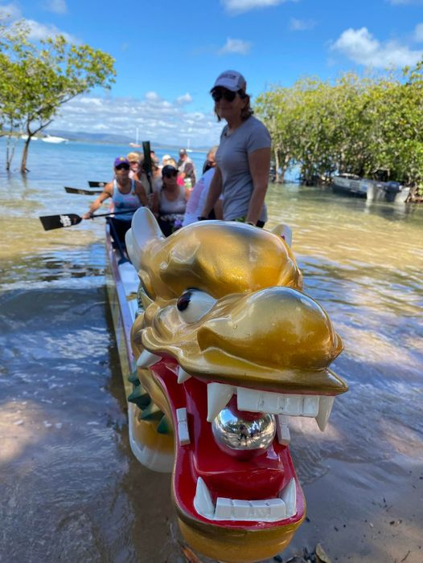
GOOD LUCK AT THE STATES

